1. Method & Data
- Trigger — amplitude-adjusted Global OECD CCI (long-run mean 100). Preferred over MCSI because its thresholds are distributionally stable (rolling c₁ range ≈4.8 units vs ≈46 for MCSI) — the property cross-market comparison requires.
- Rejected triggers: CAPE (endogenous to price), BIS credit-to-GDP gap (credit cycles are domestic, not global), VIX (one-tailed). Sentiment globalises; credit does not.
- Sample cascade: 48 markets → 27 pass Granger exogeneity → 23 admissible after T ≥ 340 obs (≈ 1998+, spanning dot-com, GFC, COVID).
- Large markets drop at the exogeneity stage (US indices, UK, DAX, CAC 40, ASX 200): their equity returns move the GDP-weighted aggregate.

2. Threshold Consistency
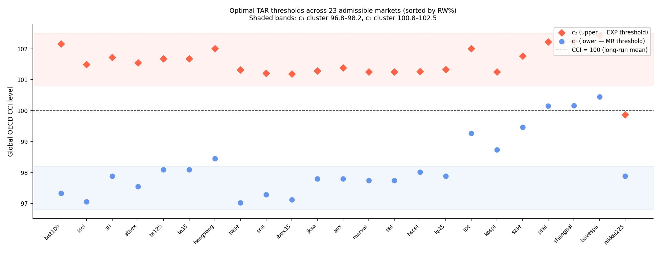
Figure 1. Optimal TAR thresholds across the 23 markets, ordered by time-in-RW share.
- Lower thresholds c₁ cluster ≈ 96.8–98.2; upper thresholds c₂ ≈ 100.8–102.5 — straddling the CCI mean of 100.
- Tight clustering means the same trigger value demarcates the same regime almost everywhere — the basis for a comparable cross-market metric.
- Upward c₁ outliers (China, Philippines, Brazil) flag markets only loosely tied to global sentiment.

3. Cross-Market Efficiency Ranking
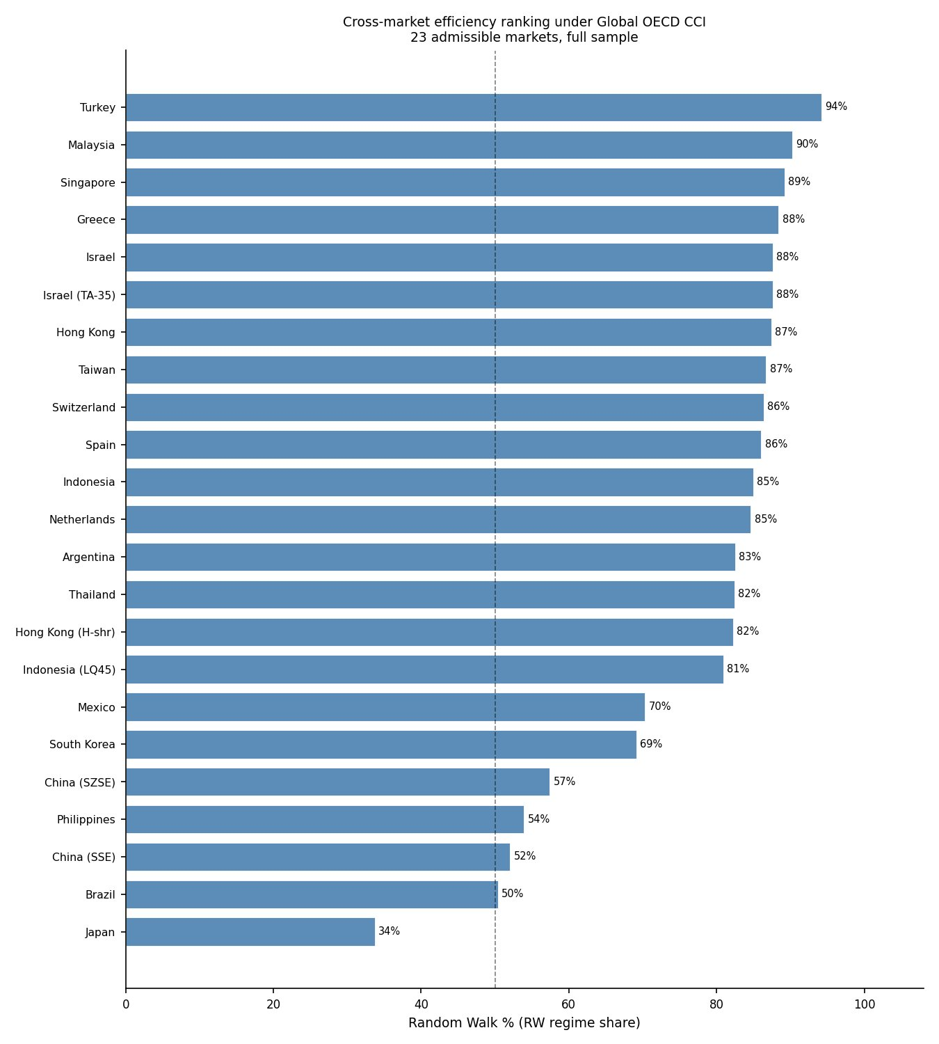
Figure 2. Share of months in the efficient (RW) regime under the Global OECD CCI.
- Time-in-RW (“efficiency”) ranges from 94% (Turkey) to 34% (Japan).
- “Efficiency” here = time in RW under this trigger, not a universal property (see Section 7 boundary).
- Verdict taxonomy: Both-tails (most markets — captures dot-com EXP and GFC MR); Euphoria gauge (Malaysia, Taiwan — EXP only); Fear gauge (Brazil — MR only).

4. Four Behavioural Categories
- Global-stress aligned (Hong Kong, Singapore, Switzerland, Spain, Netherlands, Israel, Indonesia, Malaysia, Taiwan): high RW; global episodes captured cleanly.
- Structural divergence (Japan; China SSE/SZSE): Japan 61% EXP — sentiment elevated vs deflation-era equities; China heavy MR — domestic boom-bust.
- High mean-reversion / Latin America (Mexico, Brazil, Argentina): MR from commodity & crisis cycles; Brazil degenerate — 0% EXP, effectively two regimes.
- Recent-stress capture (South Korea, Philippines): episodes across dot-com, GFC and — for the Philippines — COVID; MR shares 18% and 45%.

5. Representative Case Studies
- Hong Kong — 87% RW; brief EXP at the 2000 peak, MR at the 2008 and 2020 troughs (textbook both-tails).
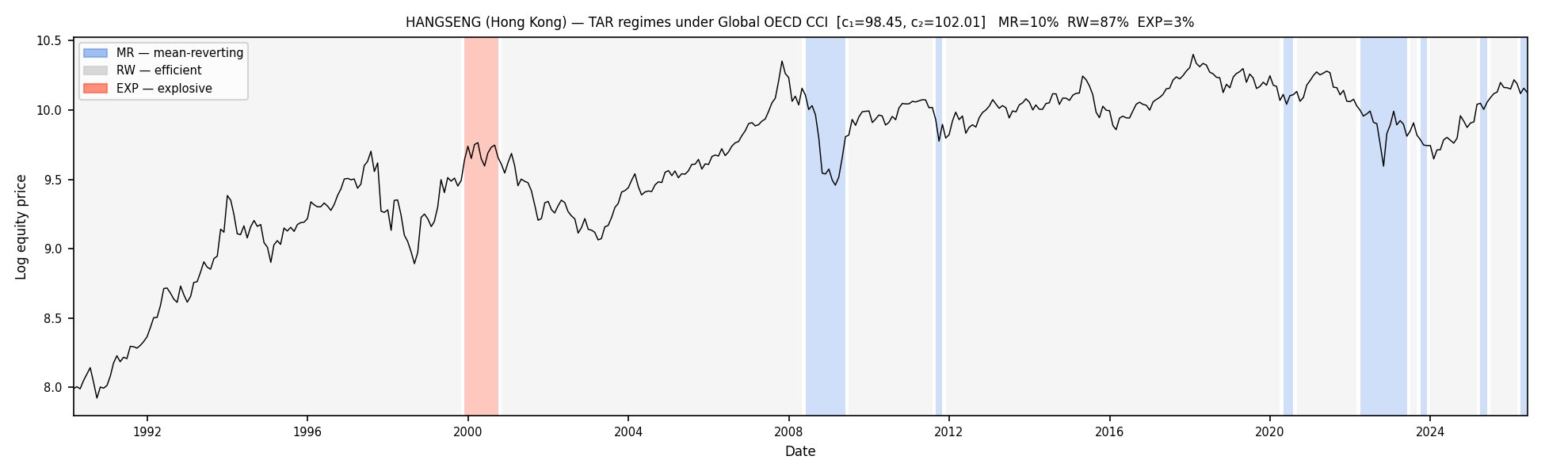
Figure 3. Hang Seng under the Global OECD CCI — RW 87%, MR 10%, EXP 3%.
- Japan (Nikkei 225) — 61% EXP, the structural outlier; post-1990 divergence of sentiment from equity returns (a real finding, not a failure).
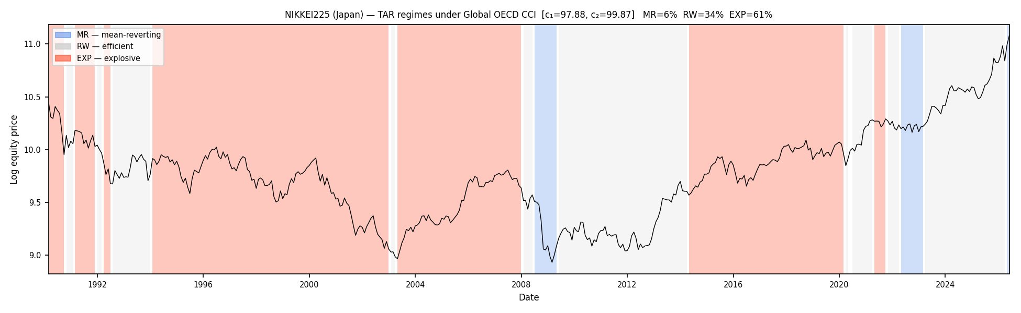
Figure 4. Nikkei 225 under the Global OECD CCI — RW 34%, MR 6%, EXP 61%.
- Shanghai (China SSE) — 47% MR / 52% RW; domestic boom-bust cycles (2007–08, 2015) read largely as mean reversion.
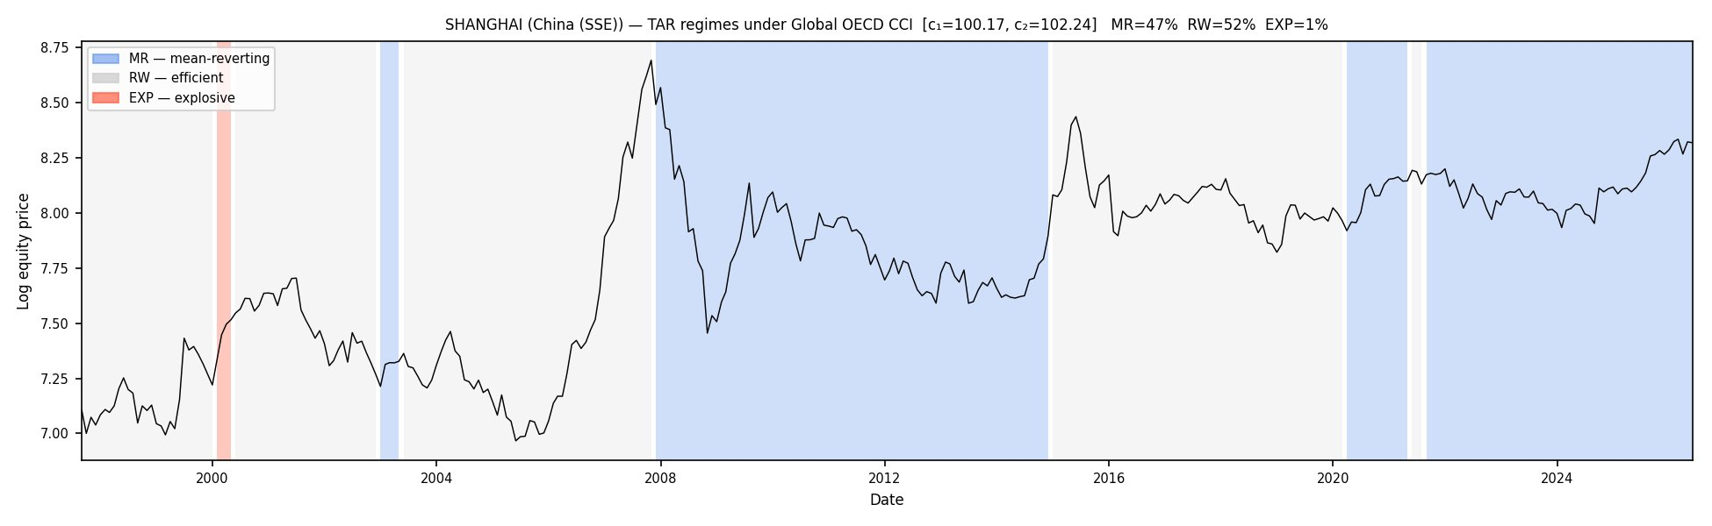
Figure 5. Shanghai under the Global OECD CCI — RW 52%, MR 47%, EXP 1%.

6. The Framework’s Appropriate Domain
- A global trigger only resolves globally-shared sentiment — regional / domestic crises are invisible and the market is mislabelled efficient.
- Diagnostic — first-difference correlation of national vs global CCI: USA 0.81 (dominates the aggregate), most OECD 0.50–0.70, Greece 0.37, Turkey 0.38, New Zealand 0.29 (low ⇒ needs a country-specific trigger).
- Greece: global CCI 88% RW / 4% MR (misses crisis) → Greek CCI 44% MR / 25% EXP / 31% RW (crisis recovered).
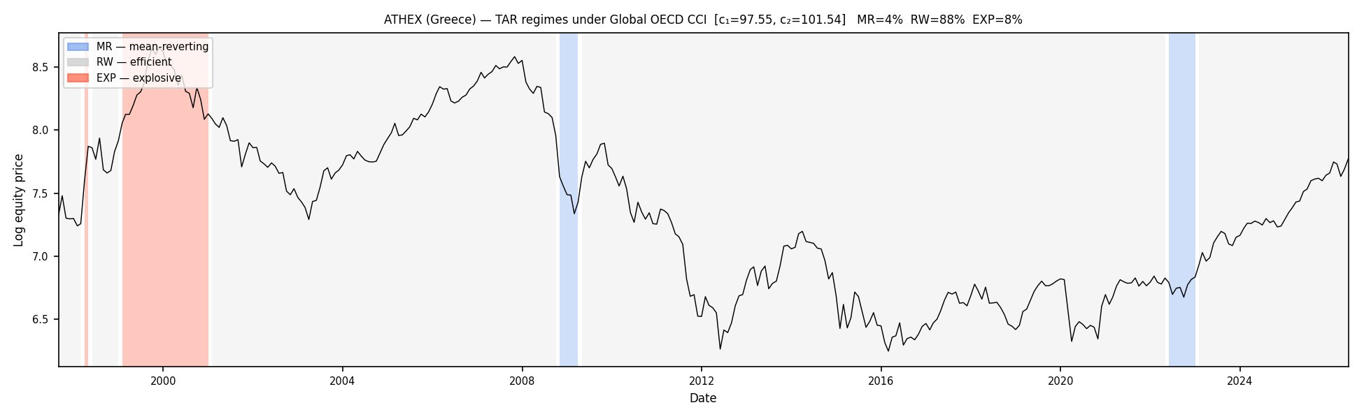
Figure 7a. ATHEX (Greece) under the Global OECD CCI — crisis missed (RW 88%).
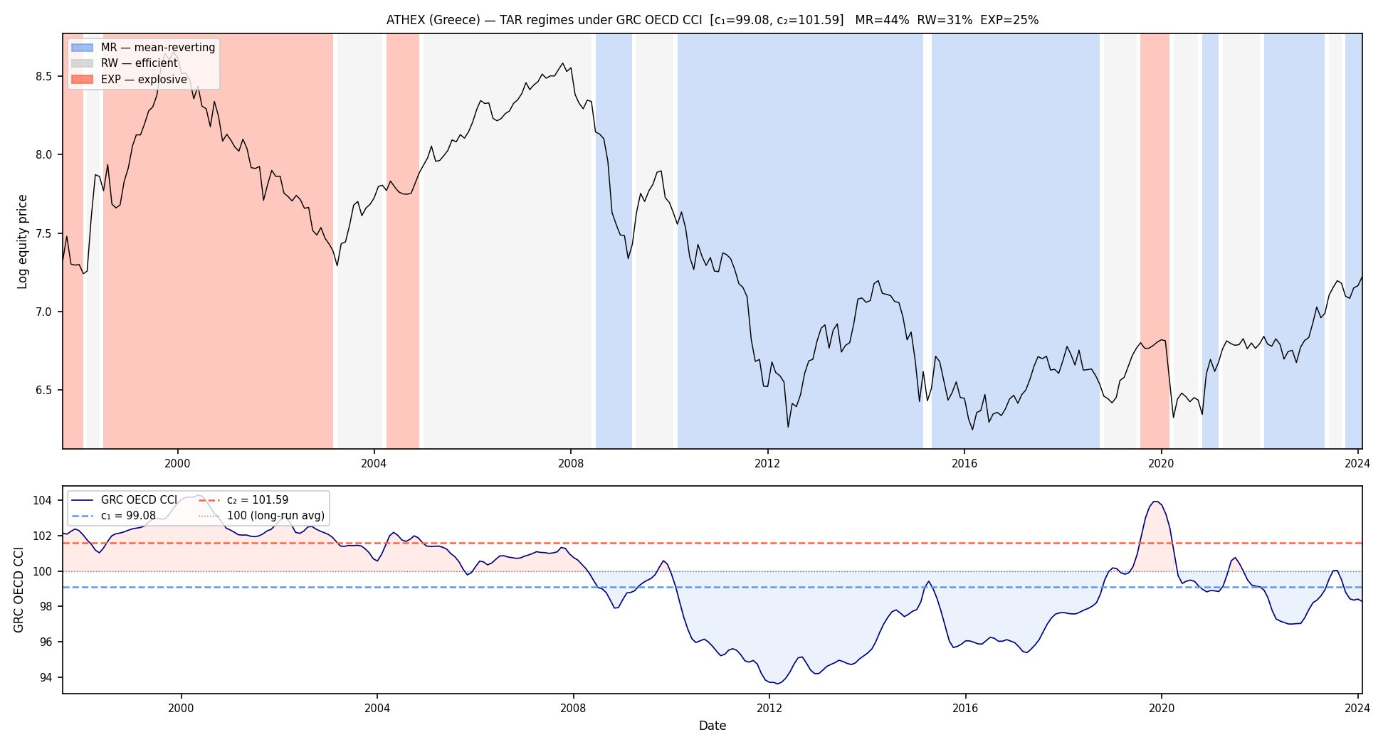
Figure 7b. ATHEX (Greece) under the Greek-specific CCI — crisis recovered (MR 44%, EXP 25%).
- Turkey: global CCI 94% RW (tops the ranking) → Turkish CCI 48% EXP / 45% RW / 7% MR (domestic boom-bust emerges).
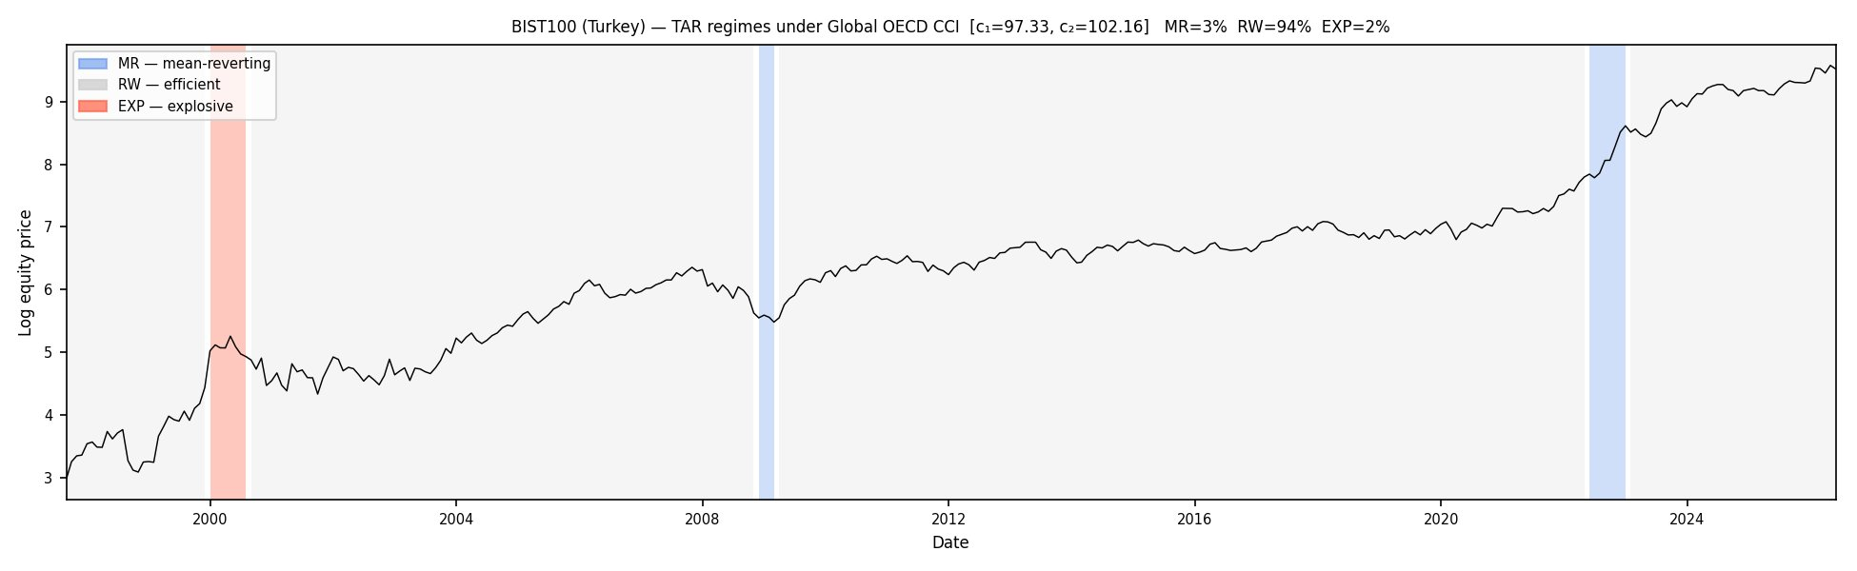
Figure 8a. BIST 100 (Turkey) under the Global OECD CCI — domestic crises invisible (RW 94%).
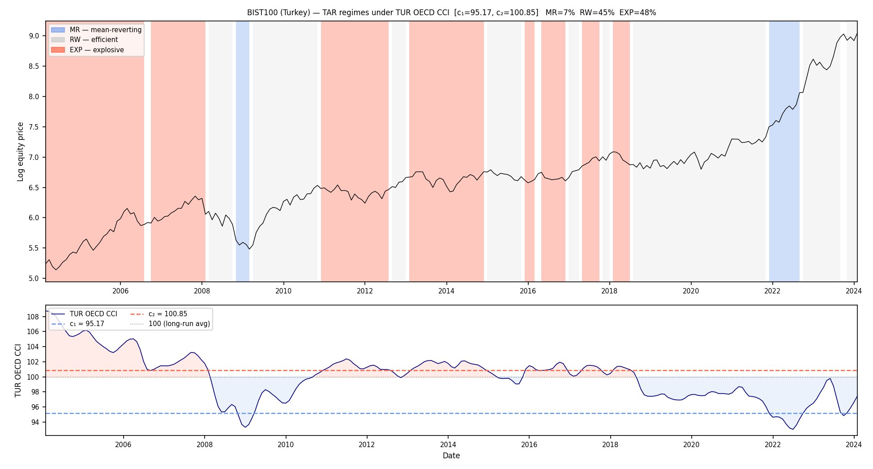
Figure 8b. BIST 100 (Turkey) under the Turkish-specific CCI — boom-bust emerges (EXP 48%).
- Cause: GDP weighting — peripheral economies carry little weight and can move opposite the aggregate.
- Proposed workflow: (1) Granger exogeneity → (2) Δ-correlation screen (~0.5) → (3) sub-period crisis validation (Spain: 0.71 overall but crisis-period divergence) → (4) implement with global or country trigger.

8. Horizon Return Test
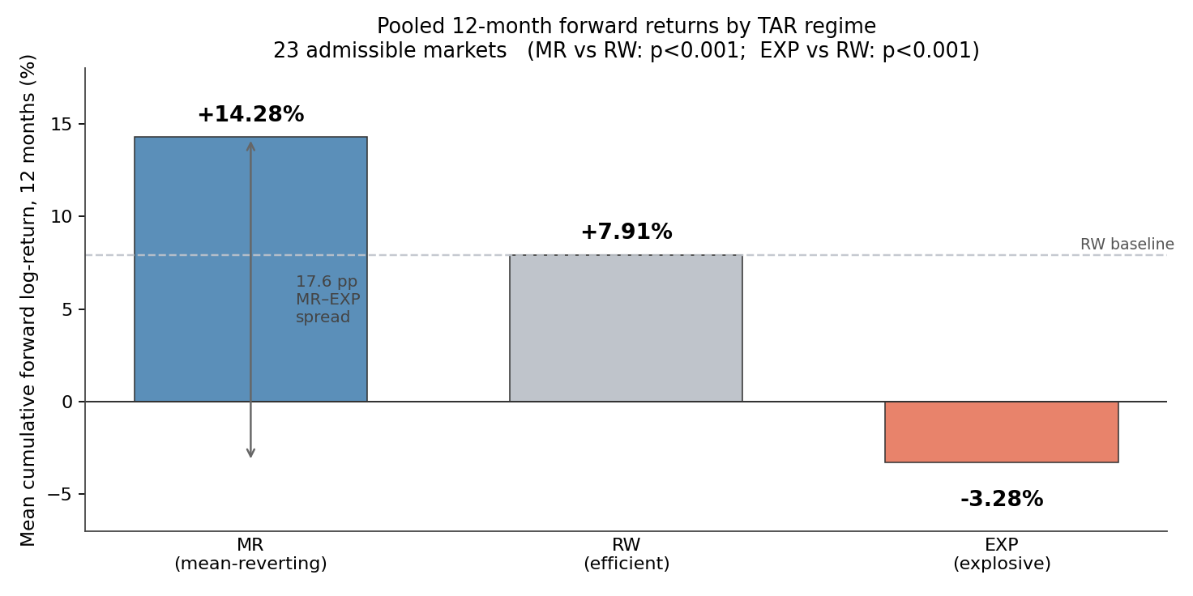
Figure 9. Pooled 12-month forward log-returns by regime across the 23 markets.
- 12-month forward returns: MR +14.3% | RW +7.9% | EXP −3.3%.
- MR vs RW and EXP vs RW differences both p < 0.001; MR–EXP spread > 17 pp.
- Regime labels carry genuine forward-return content — the validation absent from the original study.

9. Early vs Late Explosiveness
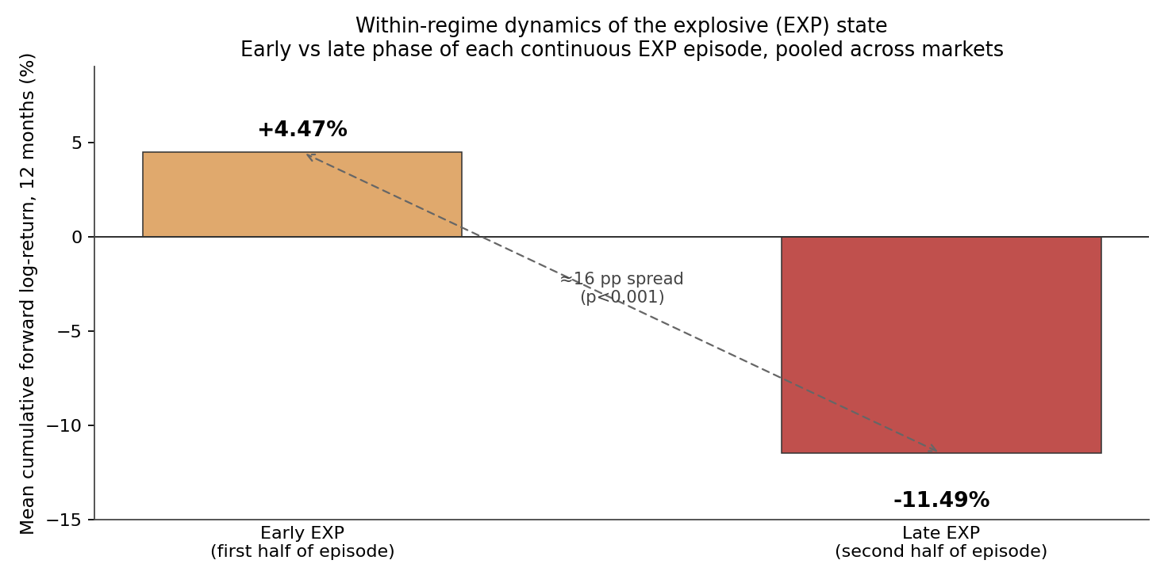
Figure 10. Early vs late phase of explosive episodes — 12-month forward returns.
- Within EXP episodes: early phase +4.5% vs late phase −11.5% (≈16 pp, p < 0.001).
- The build-up phase still pays; losses concentrate as the episode matures.
- Ex-post (hindsight) split — a descriptive anatomy of episodes, not a real-time signal.

10. Current Reading & Next Steps
- Early-2026 reading (caveated): the latest Global OECD CCI ≈ 97.55 sits below the typical c₁ of 97–98, placing most markets in MR and none in EXP — a correction/recovery reading, not a bubble signal (a classification at one trigger value, not a forecast).
- Next: country-specific CCI for Mexico / Spain / Italy; robustness (bootstrap CIs, ex-COVID sub-sample); individual equities (per supervision); integration analysis vs MSCI World.
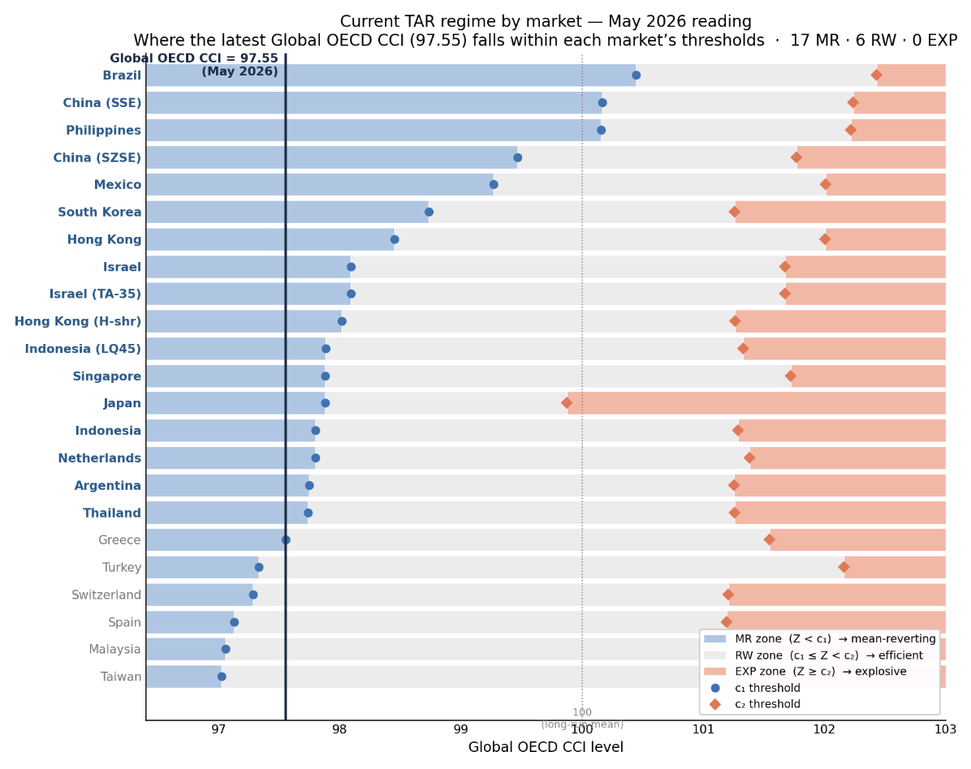

Appendix A. Historical Episode Coverage
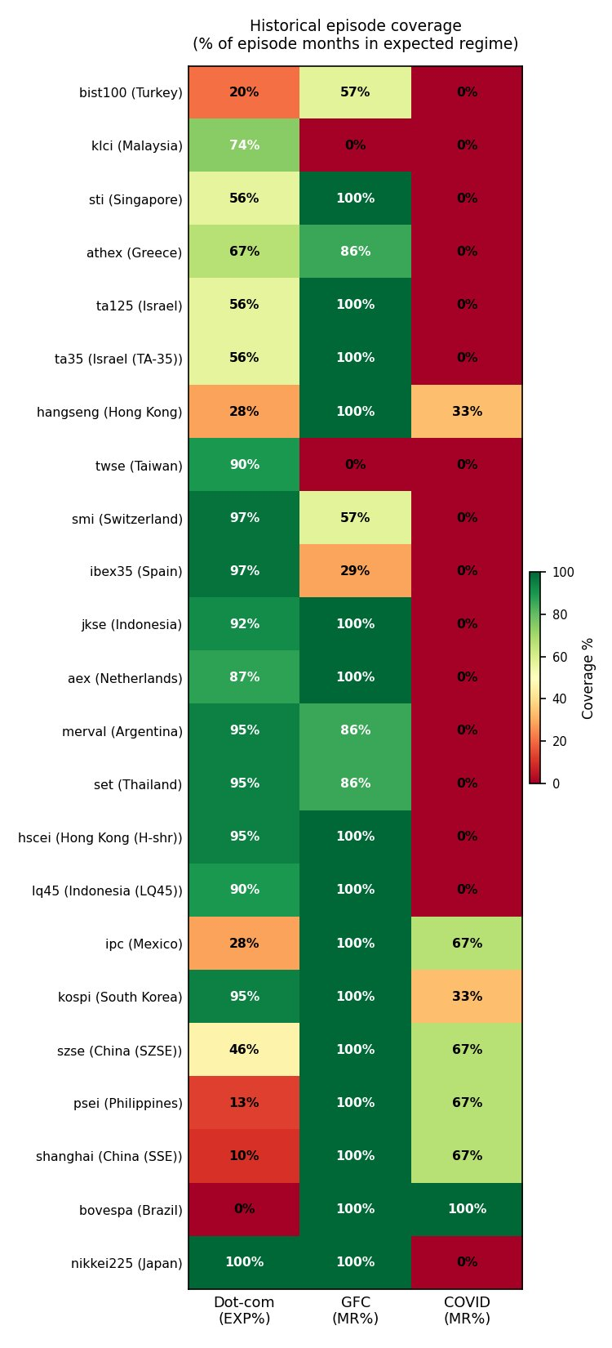
Figure A1. Share of episode months classified in the expected regime, by market and episode.
- % of episode months in the expected regime (dot-com → EXP; GFC and COVID → MR).
- Window-definition sensitive; near-zero COVID coverage reflects the sentiment–equity lag. Shown for transparency, not as primary evidence.

Appendix B. Full Results Table
Admissible panel under the Global OECD CCI, ordered by time-in-RW. Shares rounded (may not sum to 100).
Index | Country / market | RW % | MR % | EXP % | Verdict
bist100 | Turkey | 94 | 3 | 2 | Both tails
klci | Malaysia | 90 | 2 | 8 | Euphoria gauge
sti | Singapore | 89 | 6 | 5 | Both tails
athex | Greece | 88 | 4 | 8 | Both tails
ta125 | Israel | 88 | 7 | 5 | Both tails
ta35 | Israel (TA-35) | 88 | 7 | 5 | Both tails
hangseng | Hong Kong | 87 | 10 | 3 | Both tails
twse | Taiwan | 87 | 2 | 12 | Euphoria gauge
smi | Switzerland | 86 | 3 | 11 | Both tails
ibex35 | Spain | 86 | 2 | 12 | Both tails
jkse | Indonesia | 85 | 5 | 10 | Both tails
aex | Netherlands | 85 | 5 | 10 | Both tails
merval | Argentina | 83 | 5 | 12 | Both tails
set | Thailand | 82 | 5 | 12 | Both tails
hscei | Hong Kong (H-shr) | 82 | 7 | 11 | Both tails
lq45 | Indonesia (LQ45) | 81 | 7 | 12 | Both tails
ipc | Mexico | 70 | 27 | 3 | Both tails
kospi | South Korea | 69 | 18 | 12 | Both tails
szse | China (SZSE) | 57 | 37 | 5 | Both tails
psei | Philippines | 54 | 45 | 1 | Both tails
shanghai | China (SSE) | 52 | 47 | 1 | Both tails
bovespa | Brazil | 50 | 50 | 0 | Fear gauge
nikkei225 | Japan | 34 | 6 | 61 | Both tails

